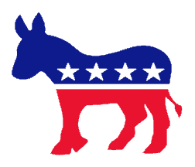
WHICH POLITICAL PARTY ARE YOU?

Which political party are you? Well, we’re about to find out! Follow the steps below (carefully!) to determine which of the 2016 candidates for the presidential election you are most like!

Steps

1. Go to my Civics page and click on the link titled “Which political party are you?”. This will take you to a website titled Isidewith.com.

2. Answer the questions in the survey. If you do not know about a certain question, click the “Learn More” button! If you’re still have trouble understanding something, take your best guess!

a. At the end of each section, it may say “Show more (insert category here) questions”. Try to answer the additional questions to get a more accurate understanding of which candidate you are more closely affiliated (linked) with and learn more about what major political issues there are.

3. When you have answered all the questions, click “Show My Results”! THIS IS SO EXCITING!

a. You should now see your results. It is in the form of a percentage with how similar you are to each of the candidates.

4. It’s time to chart your results. Get a piece of graph paper (there should be some on my desk) and create a bar or line graph representing the percentage of similarity you have to your most similar candidate as well as two additional candidates from the Republican Party, two additional candidates from the Democratic Party and one candidate from a Third Party (a party that is not a Democrat or Republican).

a. Make sure you include:
- all the candidates listed in Step 4
- a title for your graph
- clear labels for each candidate and his/her percentages
-an accurate X and Y-axis
- the graph is neat and shows a great deal of effort (feel free to use markers, colored pencils, etc.)
5. On the back, write one well–developed paragraph about 2 topics that were most important to you in the quiz, why they are important to you and what you believe regarding those topics.

If you do not finish, this is for homework, due tomorrow. Good luck!

